We have automated a workflow that allows a user to chat with an LLM agent.

**Prerequisites:**

* Mistral API

**Step-by-Step Process**

**Step-1: Create a new Workflow**

You need to select **Create Workflow** from the top left of the canvas.

A blank canvas will open.

**Step-2: Add LLM Chain**

When you click on the **+** icon on canvas, n8n will prompt you with **What triggers this workflow?** At the top of the dialog, there is a search bar where you can type any keyword to filter the available options.

Type ‘llm’ and select **Basic LLM Chain** from the trigger list.

The configuration panel will open:

The key settings are:

* Source for Prompt (User Message): Select **Connected Chat Trigger Node**
* Prompt (User Message): It takes input from input message(automatically added). It’s not editable.
* Require Specific Output Format: Keep disabled.
* Enable Fallback Model: Keep disabled.
* Chat Messages (if Using a Chat Model): You can configure one or more message types. Here, 1 type has been used for generating better output.
  + Type Name or ID: System
  + Message: Input the system prompt message to instruct the model about its role and responsibilities.

Now, click on the plus icon to add the model.

Search with the keyword “mistral” and select **Mistral Cloud Chat Model** from the list.

Following window will open:

The key settings are:

* Credential to connect with: If you already have Mistral Cloud account, select it from the dropdown. Otherwise, select **Create new credentials**.

To get the API key, go to <https://mistral.ai/> . If you don’t have any Mistral account, create a new account and sign in. After signing in, click on **API Keys** from the left-side menu.

Click on **Create new key**.

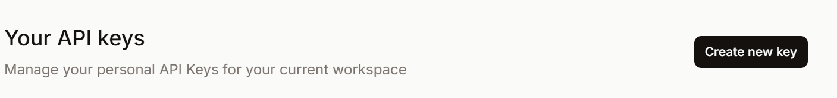

Write a name and click on **Create new key**. Don’t select any expiration date if expiration not required.

Once API key is created, copy the key and store it in a secure place.

Use this API key to create the credentials for Mistral Cloud Account in n8n.

Once credential is created, go back to the **Mistral Cloud Chat Model** configuration window and proceed with rest configuration.

* Model: Choose your preferred model (here, mistral-8b-latest has been selected) from the dropdown.
* Options: It can be left empty or can be configured if you want to fine-tune generation parameters.

Click on **Save** or press **Ctrl+S** after adding any new component or making changes, otherwise it will not be saved automatically.



Now, if can start chatting as follows:

The glimpse of a conversation is shared below,

You can also see the details as follows:

